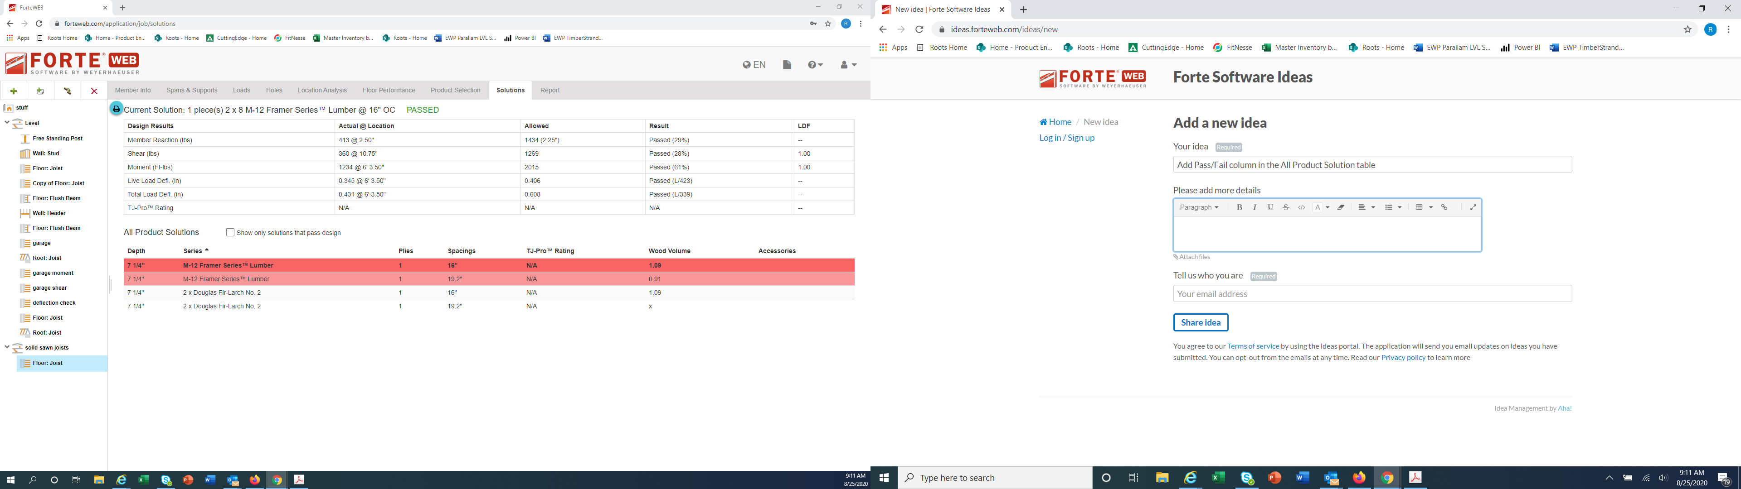

Pass

Pass

Pass

Fail

Pass/Fail